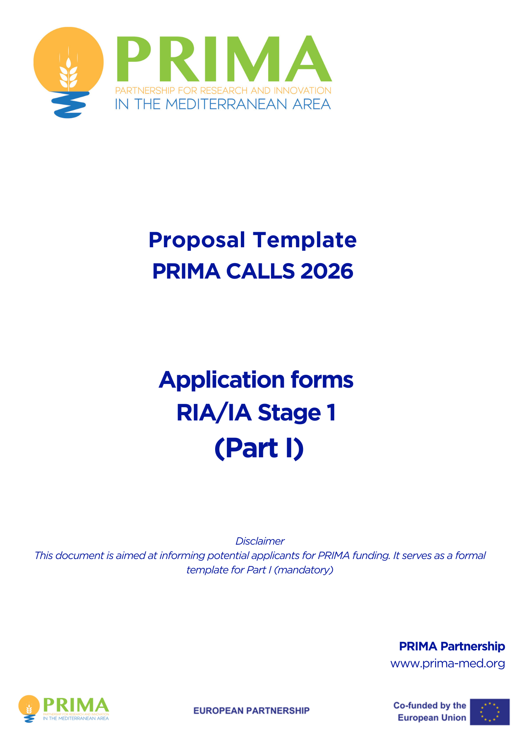

Structure of the Proposal

The proposal contains three parts:

• Part I of the proposal is the narrative sections that complement the administrative data required for submission. This document is to be completed and uploaded as an Annex in the Electronic Submission System (ESS). Please ensure that the information included in this document is fully aligned with the administrative sections entered directly in the Electronic Submission System (ESS). Both the online fields and the annexed document can be updated at any time before final submission, allowing participants to revise or complete the information progressively.

• Part II of the proposal is the technical section that addresses the three evaluation criteria (Excellence, Impact . Applicants must upload Part II as a PDF document using the template available on the PRIMA website, under the specific call or topic. Please ensure that the uploaded document strictly follows the structure and formatting requirements outlined in the template. Any deviation may affect the evaluation process.

• Budget Only the total budget is requested at stage 1. On the online submission system, for each partner, the Project Coordinator must indicate the requested amount to PRIMA and the total cost of the project (please refer to the ‘Electronic Submission System Handbook’). Please ensure that your requested contribution to PRIMA does not exceed the maximum per grant as stated in the call text. The project total cost = requested amount to PRIMA + own funding. Detailled budget is requested only for full proposals (stage 2). For section 1: A detailed explanation of eligible and ineligible costs can be found in the Art. 6 of the PRIMA Model Grant Agreement (available on http://prima-med.org/). For section 2: applicants must follow their national regulations available on http://prima-med.org/):
The Guidelines for Applicants will help you prepare your proposal, and the Electronic Submission System Handbook will provide step-by-step information on submitting your proposal. Both are available on the PRIMA official website.

The submission process consists of five key steps:

1. Log in to the ESS
Access the ESS via the webpage of your specific call topic published on the PRIMA website.
2. Verify your selection
Ensure that you have selected the correct call, topic, and type of action.
3. Create your draft proposal
Fill in the basic project information, including title, acronym, summary, main applicant organisation, and contact details.
4. Add your partners
Include all participating organisations and complete their contact information in the ESS.
5 Complete and upload your proposal

Fill in the online web forms and upload the following documents before the submission deadline:
Part I – Administrative and narrative data (Annex)
Part II – Technical Description (PDF using official template)
Budget – only the total requested amount has to be declared online on the ESS.

Timely submission and accurate alignment between uploaded documents and online fields are essential for successful proposal evaluation.

DELETE THIS INFORMATION BOX BEFORE CONVERTING YOUR DOCUMENT TO PDF

PRIMA Partnership

Application forms (Part I)

Topic:
Type of Action:
Proposal acronym:

Table of contents

Section | Title | Action
1 | General information
2 | Participants
3 | Budget

The forms must be filled in for each proposal using the templates available in the PRIMA website. It has to be uploaded to the Electronic Submission System (mandatory) before the deadline.

1 – General information

First part- provides basic data on the proposal. It can be filled in by the coordinator.

Topic Type of action
Call

Acronym is mandatory
Acronym

Max 200 characters (with spaces). Must be understandable for non-specialists in your field.

Proposal title

Duration in
Estimated duration of the project in full months.

months

keywords

Note that for this call, applicants have to select minimum 3 and maximum 6 keywords. Keywords in Part I, II and Electronic Submission System must be the same.

Abstract
The abstract should provide the reader with a clear understanding of the objectives of the proposal, how they will be achieved, and their relevance to the Work Programme. This summary will be used as the short description of the proposal in the evaluation process and in communications to the PRIMA Board of Trustees and other interested parties. It must therefore be short and precise and should not contain confidential information. Use plain typed text, avoiding formulas and other special characters. The abstract must be written in English. The Abstract in Part I document and the one on the ESS (English version) must be the same. : (Maximum number of characters allowed: 4000)

Has this proposal (or a very similar one) been submitted in the past 2 years in response to a call for proposals under any EU Programmes or PRIMA partnership, including current calls?  A `similar' proposal or contract is one that differs from the current one in minor ways, and in which some of the present consortium members are involved. | Yes | No

Declarations
These declarations must be filled in by the Project Main Contact (Project Coordinator (PC). All declarations are mandatory.

- We declare to have the explicit consent of all applicants on their participation and on the content of this proposal. | 
- We confirm that the information contained in this proposal is correct and complete and that none of the project activities have started before the proposal was submitted (unless explicitly authorised in the call conditions). | 
- We declare:  - to be fully compliant with the eligibility criteria set out in the PRIMA calls  - not to be subject to any exclusion grounds under the EU Financial Regulation 2018/1046  - to have the financial and operational capacity to carry out the proposed project. | 
- We declare that the proposal complies with ethical principles (including the highest standards of research integrity as set out in the ALLEA European Code of Conduct for Research Integrity, as well as applicable international and national law, including the Charter of Fundamental Rights of the European Union and the European Convention on Human Rights and its Supplementary Protocols. Appropriate procedures, policies and structures are in place to foster responsible research practices, to prevent questionable research practices and research misconduct, and to handle allegations of breaches of the principles and standards in the Code of Conduct. | 
- We declare that the proposal has an exclusive focus on civil applications (activities intended to be used in military application or aiming to serve military purposes cannot be funded). If the project involves dual-use items in the sense of Regulation 428/2009, or other items for which authorisation is required, we confirm that we will comply with the applicable regulatory framework (e.g. obtain export/import licences before these items are used). | 
- We confirm that the activities proposed do not  - aim at human cloning for reproductive purposes;  - intend to modify the genetic heritage of human beings which could make such changes heritable (or  - intend to create human embryos solely for the purpose of research or for the purpose of stem cell procurement, including by means of somatic cell nuclear transfer.  - lead to the destruction of human embryos (for example, for obtaining stem cells)  These activities are excluded from funding. | 
- We confirm that for activities carried out outside the Union, the same activities would have been allowed in at least one EU Member State. | 
 | 
The coordinator is only responsible for the information relating to their own organisation. Each applicant remains responsible for the information declared for their organisation. If the proposal is retained for PRIMA funding, they will all be required to sign a declaration of honour.
False statements or incorrect information may lead to administrative sanctions under the PRIMA financial procedure

2 – Participants

List of participating organisations

# | Participating Organisation Legal Name (as shown in the PIC number) | Organisation Acronym | Country | PIC Number | Type of the Organisation*
1
2
3
…..
N | (you can add extra rows when needed)

*Type of organisation: Secondary and higher education establishments (HES); Research organisations (excluding education) (REC); Private for-profit companies (PRC); Public bodies (excluding research and education) (PUB); Other entities (OTH)

The Coordinator has the rights to:
- add, delete, edit and re-order partners in the consortium
- add, delete, edit and re-order contact points for those organisations
- edit all sections of the administrative forms
- upload, delete, view and download all proposal forms (Part I & II, Annexes, Budget Template)
- submit the proposal on behalf of the consortium members
Participant can:
- view all the information, but not edit it
- edit only the section for their organisation in the administrative forms on the ESS
- view the entire administrative forms
- view/download the Part II and other Annexes

You can manage the list of participating organisations and access rights of persons at the submission process. You may identify and give access to as many contact persons of the selected participating organisations as you wish. The identification is based upon the e-mail address of the contact person(s) you add to the online submission system. When you add a contact person, you will be prompted to supply the contact details: name, e-mail .

Person in charge of the proposal (main contact person = Principal Investigator PI): Each organisation needs to have one main contact person identified; the main contact person will have to fill in full contact details in the administrative form. The 'Main Contact Person' for the coordinating organisation (Participant no. 1) will become the primary contact person (Project Coordinator). Other contact persons may also be identified and may receive read-only or full access rights. Contact persons with full access rights of the coordinator (Participant no. 1) will be called 'Coordinator contacts' in the ESS, while for the other participants 'Participant Contacts'; contact persons with read-only rights will be called 'Team Members'. Other contact persons are listed with basic details in the administrative form.

Access rights: The main contact person (Project Coordinator) and contact persons of the coordinator with full access rights have the same level of rights: they can manage the list of participants and contacts, edit any part of the administrative part of the proposal and upload any attachments (e.g. Part II - technical description) and submit the proposal on behalf of the consortium. Contact persons with read-only rights can only view/download the information. Participant contacts with full access rights can only edit their section of the administrative form and view all proposal data.
Access rights can be revoked by the Coordinating Organisation contacts. The person who created the proposal cannot be deleted.

Invitation: All contacts will receive an e-mail and a notification to the ESS about the invitation to the proposal upon saving the data .

3 - Budget

TOTAL Requested PRIMA contribution to eligible costs (Requested grant amount) - | EUR 0,00

9-digit number serving as a unique identifier for organisations (legal entities) participating in EU funding programmes. If needed, one can apply for a temporary PIC on https://ec.europa.eu/info/funding-tenders/opportunities/portal/screen/how-to-participate/participant-register A search tool for organisations and their PICs is available on the same link

