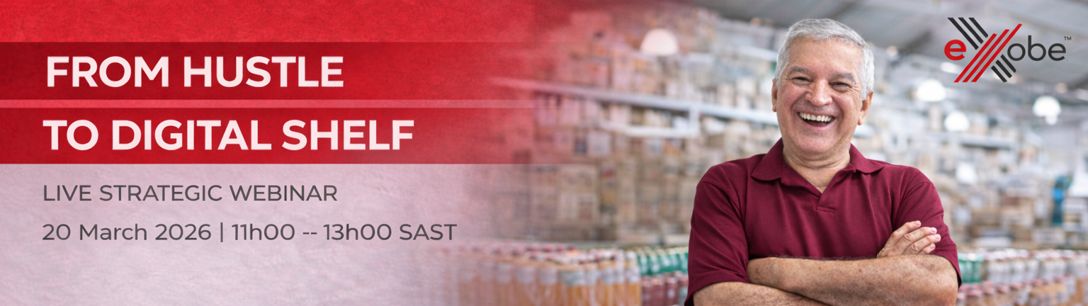
Dear Entrepreneur,

South Africa’s retail landscape is undergoing a structural shift.
Online retail is no longer a peripheral channel. It is becoming embedded in everyday buying behaviour. Consumers increasingly expect mobile-first browsing, transparent pricing, clear delivery pathways, secure payment options and responsive customer service.

The hustle exists.
The product exists.
The demand exists.
What often does not yet exist is structured digital positioning.

On Friday, 20 March 2026, we invite you to join a live strategic working session designed to help entrepreneurs move from informal selling to credible online retail participation.

FROM HUSTLE TO DIGITAL SHELF
20 March 2026 | 11h00 - 13h00 SAST

This is not a motivational webinar. It is an execution-focused engagement grounded in real operational realities.

During this session, you will gain clarity on:
- What “online-ready” actually means in practical terms
- The operational standards required to compete credibly online
- Pricing discipline and margin protection in digital environments
- Delivery economics and fulfilment feasibility
- Common positioning mistakes startups make when entering marketplaces
- How to build trust, responsiveness and long-term digital credibility

You will also experience a structured, live demonstration of the eXobe marketplace, including the seller journey, verification requirements, product listing standards and onboarding pathway.

If you are serious about positioning your business for structured digital trade RSVP here: https://events.teams.microsoft.com/event/b26102ac-cd2c-4d77-b695-9d059cb41cf2@7271e4dd-6a00-4cdc-815b-2c420802d43c/

Beyond the session itself, eXobe is actively onboarding a focused group of founding sellers.

You have built the product.
You have tested demand.
You have made sales.

However, moving from selling to competing online requires a different level of alignment. Many strong businesses struggle not because their product lacks value, but because pricing, catalogue structure, fulfilment readiness and digital presentation are not yet configured for credible marketplace participation.

That gap is where growth stalls.
eXobe is building an entrepreneur-first business network designed to support credible brands ready to compete properly in online retail. Before scaling buyer traffic aggressively, our priority is strengthening supply, working closely with selected businesses to ensure their products are positioned correctly from day one.

Early sellers benefit from:
- Dedicated onboarding support
- Practical positioning and catalogue guidance
- Structured verification that protects strong brands
- Stronger early visibility within the platform
- Opportunity to grow alongside phased buyer activation
- This is structured participation, not mass listing.

If your business is ready to compete credibly and scale with intention, you may apply directly:
https://exobe.africa/sell

You may also book a guided onboarding session with our team for step-by-step advisory support during our live Wednesday onboarding clinics. We are building deliberately with entrepreneurs serious about growth, discipline and long-term competitiveness.

The digital shelf is not about technology alone.
It is about readiness, credibility and operational structure.

The Future of Business Has a Network.
It’s eXobe.

