**Wheat cultivars: Ratel, Steenbok, Tredou**

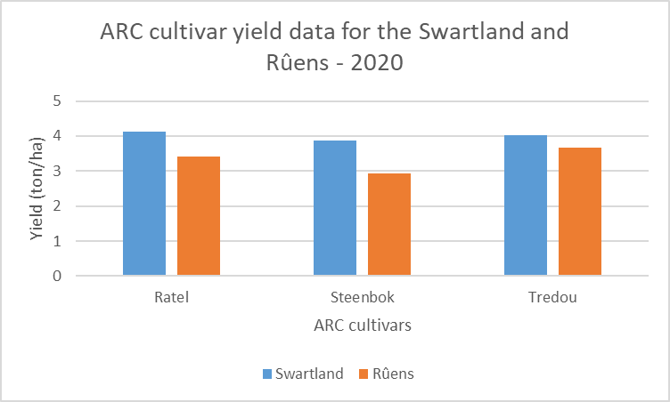

**Figure 1. ARC cultivar yield data for the Swartland and Rûens for the period 2019 – 2020**