COORTech Reactor System

The COORTech Reactor System developed at the Cape Peninsula University of Technology is a one-step waste water treatment system consisting of highly reactive nanoparticles immobilized in a specialised reactor system for the purpose of treating industrial wastewater. The system utilizes a nanoparticle catalyst, which activates an oxidizer in order to produce sulfate radicals that attack and degrade inorganic pollutants (such as dyes) in the wastewater. The system allows the re-usage of effluent water in one continuous process, thereby reducing the use of input water and lowering operating cost.

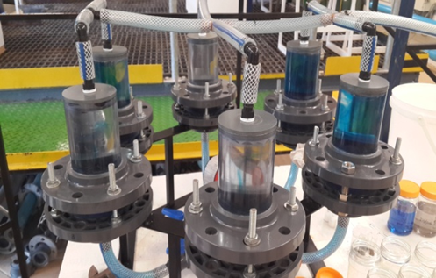

Benefits
- The technology eliminates the extra operating step and cost of removing catalyst residues and sludge from the effluent water
- The system does not produce by-products which fouls the membranes
- The reactor operates at a competitively low pressure (max 4kPa) relative to membrane technology, which requires a minimum pressure of 100kPa
- The COORTech reactor can be incorporated into existing wastewater treatment plants
Offering
We are seeking investors who would like to invest in a new spin off company directed at manufacturing reactors and servicing industrial wastewater plants
Inventor(s): Professor Veruscha Fester; Dr Mahabubur Chowdhury; Gunner Visser
Intellectual Property Right: South Africa ZA2016/04800

