Bambara Nut Probiotic Beverage
BamPro is a natural, great tasting, lactose and cholesterol free yoghurt-like drink. It is naturally low in fat and rich in protein, fibre and anti-oxidants with added probiotics for maintaining good balance and composition of intestinal flora. BamPro is produced from whole milled Bambara fermented with lactic acid bacteria to produce Bambara groundnut probiotic beverage. It contains all the goodness of the seeds especially the pigments on the hulls that includes phenolic and flavonoids contributing to nutritional well-being of the consumers. Further, it is high in proteins and total dietary fibre with anti-oxidant activity, which protects the probiotics during storage and provides a longer shelf life of 28 days at 5°C.

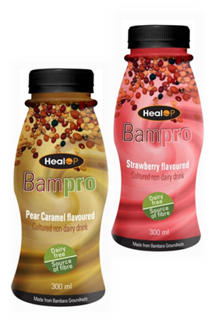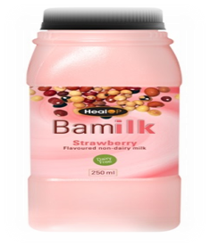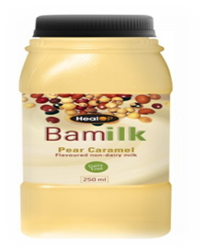

Benefits
- Used to produce range of non-diary probiotic products including beverages, in scoop-able, drinkable and frozen forms with different flavours
- Addresses problems of lactose intolerance and the unfavourable cholesterol dairy products
- Targets increasing demand for vegetarian probiotic products
- It can serve as a replacement for dairy product to individuals with milk allergy, vegetarians and health conscious individuals

Offering
We are seeking investors who would like to invest in a new spin off company directed at manufacturing and distributing a range of Bambara-based products
Inventors: Professor Victoria Jideani; Yvonne Murevanhema
Intellectual Property Rights: South Africa: ZA2013/00683

